Steps to use Gaze and Dwell feature

Step 1:

Setup scene with JioMixedReality Prefab

Step 2.

To interact with UI or any game gameobject you must attach JMRGazeAndDwellInteratable.cs script

On gameobject or UI that you want to interact with

Step 3

Switch to Gaze pointer mode you will get below popups

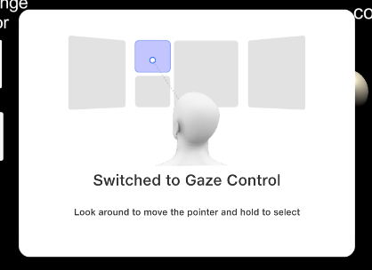

Step 4. Focus cursor on interactable gameobjects(on which JMRGazeAndDwellInteratable.cs is attached)



Note:  
1. If the interactable gameobject is UI button, then after focusing the cursor it will trigger OnClick method on the button

2.If the interactable gameobject is not UI then you can implement ISelectHandler or IselectClickHandler interface

